**Project Report**

**A-Z Household Services**

**Student Details:**

Name: Nimish Tilwani

Roll no.: 23f2003549

Email Id: 23f2003549@ds.study.iitm.ac.in

**Problem Statement**

The objective of this project was to create a web-based service management system where users can book various services, professionals can manage their assigned tasks, and an admin can oversee all activities. The system needed functionalities for user registration, service booking, service status tracking, rating professionals, and generating visual summaries of service statuses.

**Approach**

1. Planning: Defined the key functionalities and roles: users, professionals, and admins. Created a database schema to manage users, professionals, services, and service history.

2. Frameworks and Libraries Used:

1. Flask: A lightweight WSGI web application framework for Python, used to build the web application.
2. SQLite: A C-language library that provides a relational database management system, used for data storage.
3. Jinja2: A templating engine for Python, used for rendering HTML templates.
4. Bootstrap: A front-end framework for developing responsive and mobile-first websites, used for styling and layout.
5. Chart.js: A JavaScript library for creating dynamic, interactive charts, used for data visualization.

Implementation Steps-

1. Setup and Configuration:

* Initialized the Flask application.
* Configured SQLite as the database.
* Created the necessary database tables (users, professionals, services, service_history).

2. User Authentication:

* Implemented routes for user and professional login, registration, and logout.
* Used sessions to manage user authentication.

3. Service Booking:

* Created routes for users to view and book services.
* Implemented HTML forms for service booking.
* Stored booking details in the service_history table.

4. Service Management:

* Created admin routes to manage services and professionals.
* Implemented functionality for the admin to update service prices.
* Added routes for professionals to view and manage their assigned services.

5. Rating System:

* Implemented a rating system where users can rate professionals after service completion.
* Stored ratings in a dedicated table and updated professional profiles accordingly.

6. Summary and Visualization:

* Created summary pages for users, professionals, and admins.
* Used Chart.js to generate interactive bar charts showing the status of services (e.g., open, assigned, closed).
* Fetched data from the database and passed it to templates for rendering charts.

**ER Diagram:**

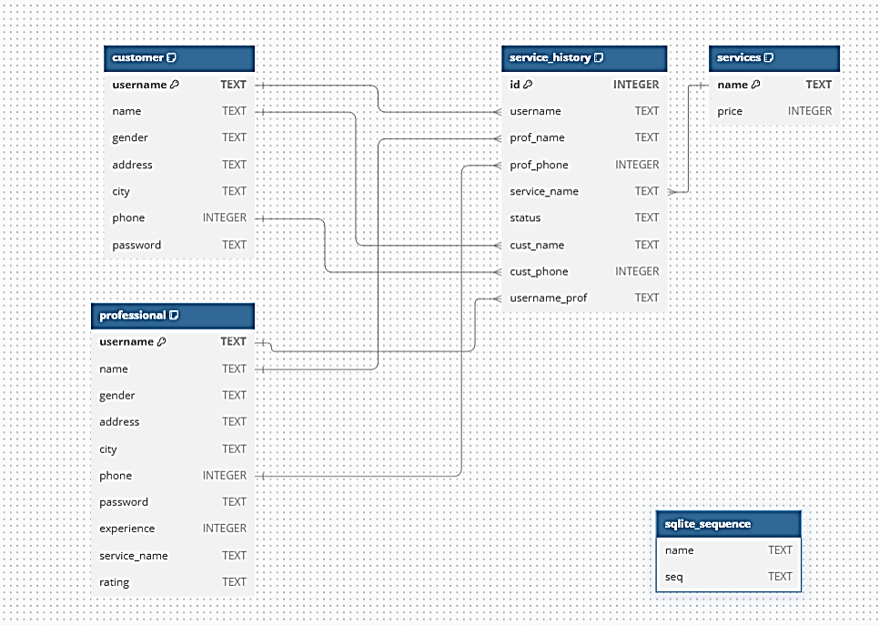

**Conclusion:**

This project demonstrated the use of Flask for building a web-based service management system, with SQLite for data storage and Chart.js for data visualization. The system allows users to book services, professionals to manage their tasks, and admins to oversee all activities, providing a comprehensive solution for service management.

**Video Link**:

https://drive.google.com/file/d/11hwWjK1hiYRgCbQntd6f4e-sWSy1MYdP/view?usp=sharing